**Planning and Design**

**General ethos**

This website’s aim is to create a simple yet colorful experience to attract children and make them more interested in puzzles. The website is to make kids more attracted to puzzles by simply offering them a friendly experience that offers what they need when they need it.

The design is in general inspired by a simple rule “K.I.S” (Keep it simple).

**Site Map**



Figure 1. Website Sitemap

The structure proposed for the website in Figure 1 above is favorable as it accommodates with the website as it grows on further maintaining its order and allowing for various developers to work at the same time in their respective folder.

**Accessibility**

The website is to address accessibility issues by doing the following:

- Adding alternative tags for all important non-decoration images

- Adding support for access keys to facilitate navigation between pages

- One key for each respective web page in the website (7 access keys)

- Using colours with high contrast

- Not depending on specific colours that would not be visible or distinguishable for colour blind users

**Design Mock-ups**

**­­­­**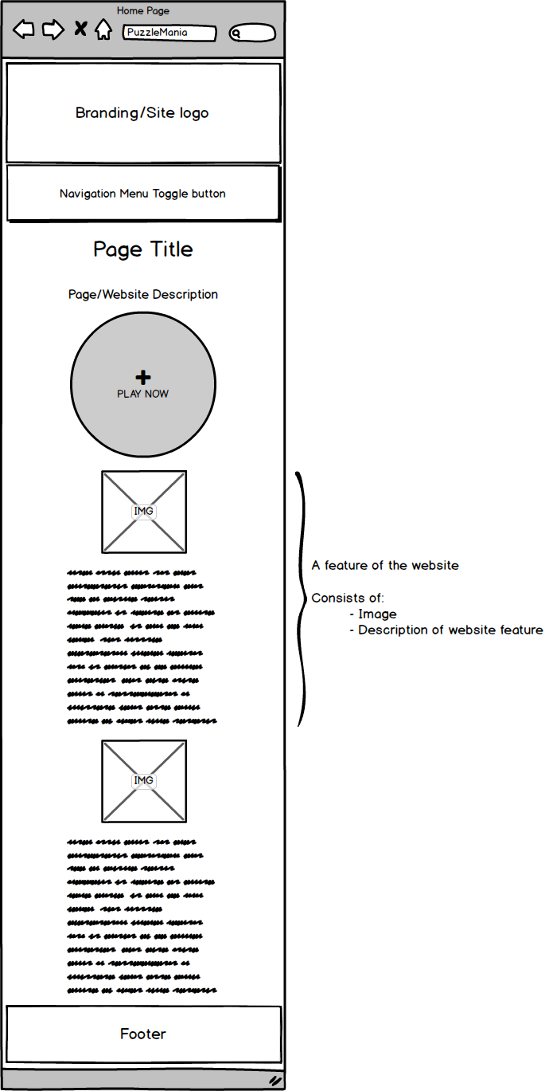

Figure 2- Mobile-first Homepage

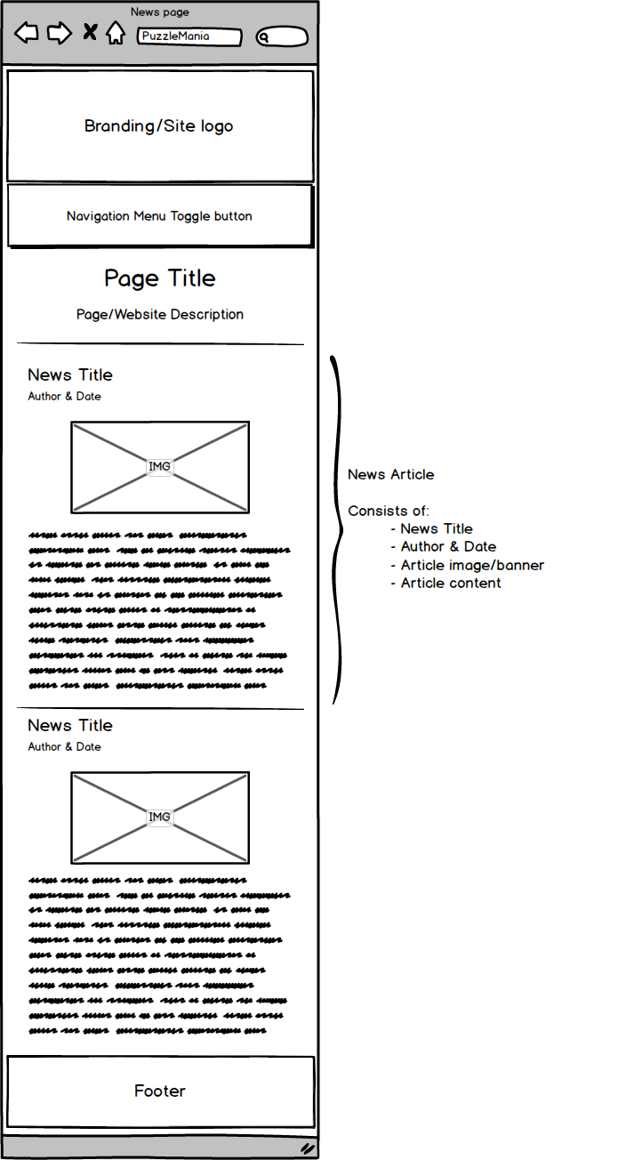

Figure 3- Mobile-first News Page

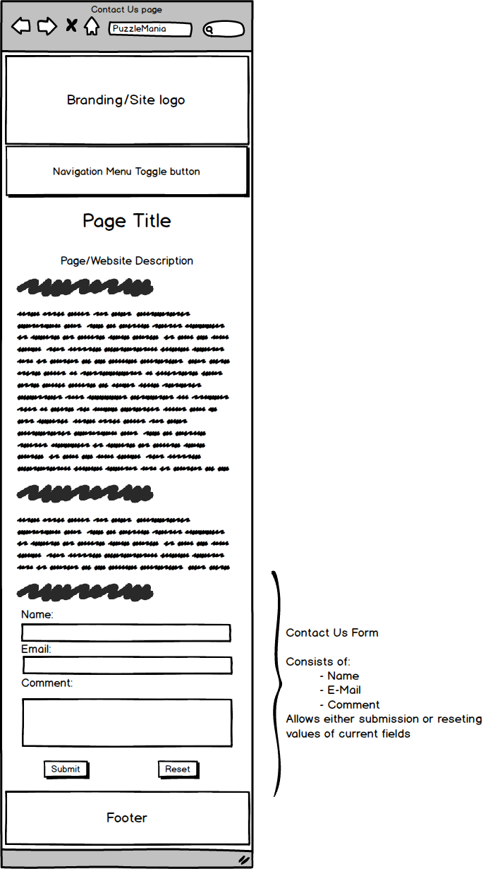

Figure 4- Mobile-First Contact Us Page

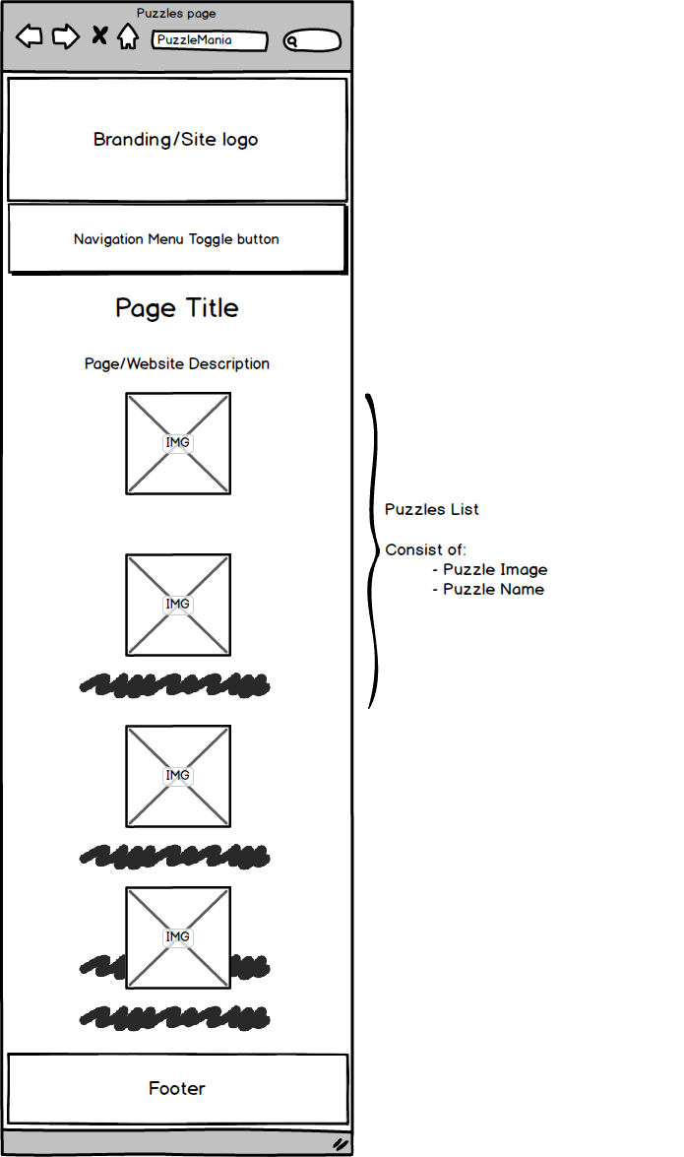

Figure 5- Mobile-First Puzzles List

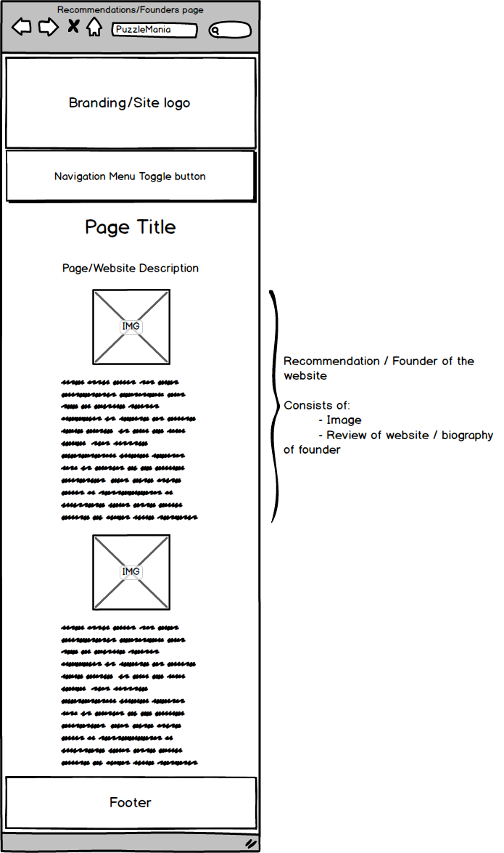

Figure 6- Mobile-First Recommendations/Founders page

Shown above are 5 figures representing the intended design philosophy for the website. The header and footer both remain the same in both the mobile and desktop designs. However, the navigation bar is to collapse to a button-operated navigation menu on mobiles and expand to a full navigation bar on desktops.

As for the content, on mobiles they’ll be displayed in columns after each other while on the desktop they are to be represented along the same row.

Design breakpoints:

There will intentionally be one major breakpoint at which the website turns from its mobile version to the desktop version. This point is intended to be at 1000 pixels wide which is an appropriate size for a desktop/laptop screen. The website should not go smaller than 320 pixels wide since almost no devices use that size anymore and stop increasing in size after it reaches 2000 pixels wide which is appropriate for majority of devices in the current market.

**Menu System:**



Figure 7- The Navigation Menu System

The menu system that I believe is most appropriate for my site is “The Toggle” (represented in Figure 7) menu system. This is basically a relatively stylish and elegant approach which is why I decided to pursue it. It has many advantages like being elegant and it scales properly for mobiles and tablets and doesn’t eat up a big chunk of the display when the user doesn’t need or want to navigate to a different page on the website.

Figure – Opening a puzzle

As for the puzzles, a small navigational system is to be set up. To be able to open a puzzle, you’ll need to go through the list of puzzles, choose the puzzle you would want to play then play the puzzle.

**Puzzle Game Design:**

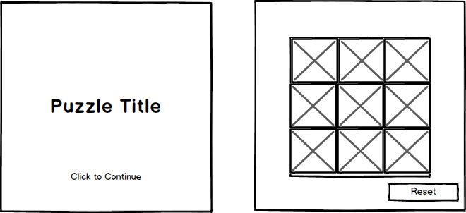

Figure 9 - Puzzle Game Deign

The game chosen to be implemented Is the sliding puzzle game.

The game is to be designed in a very simple design. The idea behind that is to both adjust for children and for disabled users making the game as easy as possible to play with.

The users are to first encounter a very clear splash screen where they click anywhere on the canvas to start the game. On starting, the game randomizes the new image and shows it in the middle of the screen and each block is to have its own border to make it more clear where the cells start and end.

To make the game accessible:

- Colours with high contrast are to be used

- Fonts and text formatting to be used is clear and simple